UMKC Chatbot: Statement of Work

Group 2

University of Missouri – Kansas City

COMP_SCI5588: Data Science Capstone

Yugyung Lee

January 29, 2024

# UMKC Chatbot: Statement of Work

1. **Introduction**

The traditional university website, brimming with static pages and dense FAQs, often fails to deliver the dynamic, personalized experience desired by prospective and current students. Enter the chatbot: a virtual assistant capable of revolutionizing how universities engage and inform their student body. Imagine students effortlessly navigating through complex course availability and fee structures, receiving instant updates on ongoing research projects, and discovering vibrant extracurricular activities - all within a single, conversational interface. Chatbots bridge the gap between information overload and accessible knowledge, enhancing engagement and streamlining student life. With instant responses, 24/7 availability, and the ability to cater to diverse learning styles, chatbots offer a potent solution for universities seeking to foster a dynamic, informed, and connected student community.

1. **Background and Significance**

In the rapidly evolving landscape of higher education, universities are constantly seeking innovative ways to enhance the overall experience for their students. One pivotal aspect is the accessibility of information related to courses, fees, and university activities. Recognizing the growing need for streamlined communication, the integration of a chatbot on a university website emerges as a pivotal solution. This intelligent virtual assistant serves as a user-friendly interface, empowering students to effortlessly inquire about course availability, obtain comprehensive details on fee structures, and gain insights into the diverse range of academic programs offered. By providing instant responses and facilitating real-time interaction, a chatbot becomes an indispensable tool in eliminating the hassle associated with traditional information retrieval methods, thereby fostering a more efficient and student-centric approach to accessing crucial university-related information.

Moreover, beyond the realm of academics, a university chatbot plays a pivotal role in keeping students abreast of the vibrant extracurricular landscape. From upcoming events and sports activities to cultural festivals and club meetings, the chatbot serves as a centralized hub for all things related to campus life. This dynamic feature enhances student engagement and fosters a sense of community within the university. Furthermore, the chatbot can showcase highlights of ongoing research endeavors and academic achievements, offering students a glimpse into the cutting-edge work being conducted by faculty members. By seamlessly integrating into the university's digital ecosystem, a chatbot not only enhances accessibility but also contributes to a more connected and informed student body, embodying the university's commitment to excellence in education and holistic development.

1. **Objectives**
2. **Course Information and Fee Structure:** The primary objective of the chatbot is to enable students to easily access information about the various courses offered by the university. It should provide detailed insights into the curriculum, prerequisites, and any special requirements for each course. Additionally, the chatbot should furnish accurate and up-to-date fee structures, ensuring that students have a clear understanding of the financial aspects associated with their chosen programs.
3. **Extracurricular Activities and Events:** The chatbot should serve as a comprehensive guide for students seeking information on extracurricular activities, events, and clubs within the university. By providing real-time updates on upcoming events, meeting schedules for clubs, and details about sports and cultural activities, the chatbot enhances student engagement and promotes a vibrant campus life.
4. **Research and Academic Highlights:** Another crucial objective is to showcase the university's academic and research achievements. The chatbot should offer summaries of ongoing research projects, highlight recent publications, and provide links to academic achievements, ensuring that students are aware of the institution's academic prowess and advancements.
5. **Interactive Q&A and Guidance:** The chatbot should facilitate interactive Q&A sessions to address specific queries from students. This includes answering questions related to admission procedures, scholarship opportunities, and any other general inquiries. Moreover, the chatbot can guide students on the application process, deadlines, and necessary documentation, offering personalized assistance.
6. **User-Friendly Navigation**: An essential objective is to ensure the chatbot's user-friendliness, making it easy for students to navigate and find relevant information seamlessly. The chatbot should have a clear and intuitive interface, allowing users to input queries in natural language and receive accurate responses promptly.
7. **Integration with University Systems:** To enhance efficiency, the chatbot should be integrated with the university's existing systems and databases. This integration ensures that the information provided is always current and aligned with official university records, minimizing the chances of misinformation.
8. **Feedback Mechanism:** Implementing a feedback mechanism within the chatbot allows students to provide insights on their experiences and suggest improvements. Regularly collecting and analyzing feedback helps in refining the chatbot's performance and ensuring that it continues to meet the evolving needs of the student community.

By aligning with these objectives, the chatbot becomes a valuable and versatile tool, offering comprehensive support to students in various aspects of their academic journey.

1. **Scope**
2. **Definition**

This project endeavors to design, develop, and thoroughly assess an intelligent chatbot tailored for university websites, with a focus on enhancing the overall student experience. The chatbot aims to efficiently provide information on course availability and fee structures, facilitate easy access to details about extracurricular activities, and showcase highlights of ongoing research and academic work within the university.

1. **Limitations**
2. Application constraints: Since the bot is specifically built to answer queries on University of Missouri Kansas City, it cannot be reused as a generic bot for other universities. Structure can be replicated but many features might need rebuilding based on the complexity of other university websites.
3. Hallucination: Chatbot may face challenges related to hallucination as it is an extension of Llama2, where it generates information that appears coherent but is not grounded in actual data. This phenomenon can lead to the dissemination of inaccurate or misleading details, especially in dynamic environments such as universities where information is subject to frequent updates.
4. Language Constraints: Initially, the chatbot will support English language interaction only, with plans for multi-language support in future project iterations.
5. **Data Sources**
6. University Data: Scraping University related information by building a custom web-scraper. This dataset can be used to fine-tune Llama2.
7. Chat History: Storing chat history and analyzing frequently queried questions to provide better query experience for users.

By clearly defining the project's focus, acknowledging its limitations, and specifying the data sources we will utilize, we aim to set realistic expectations and provide a comprehensive roadmap for project implementation.

1. **Methodologies**
2. Advanced Natural Language Processing (NLP): Employ state-of-the-art NLP techniques, utilizing transformer architectures to ensure the chatbot understands and responds contextually to university-specific queries. Fine-tune large language models, such as Llama2, to enhance performance in providing accurate and tailored information. Implement speech-to-text functionalities to enhance user engagement, allowing for a dynamic conversational flow and accommodating users who prefer voice-based interactions.
3. Comprehensive API Integrations: Integrate Replicate API to leverage the capabilities of the Llama2 model, ensuring that the chatbot benefits from the latest advancements in language understanding and generation.
4. User Experience (UX) Design Principles: Prioritize universal design principles using streamlit to ensure the chatbot is accessible to users with diverse abilities and limitations. Implement features like speech-to-text for improved accessibility.
5. Human-Centered Design: Involve end-users in the design process through interviews and usability testing to gather feedback and ensure the interface meets their specific needs.
6. Data-Driven Personalization: Extract meaningful features from user interactions and historical chat data to enhance the effectiveness of personalization algorithms, ensuring that the chatbot tailors responses based on individual preferences. Leveraging PostgreSQL to achieve this.

**Timeline**

1. **Week 1-2**: Requirement gathering and literature review.
2. **Week 3-4**: Initial design and prototype development.
3. **Week 5-6**: Developing web-scraper and cleaning data to train.
4. **Week 7-8**: Fine-tune Llama2 model with training data.
5. **Week 9-10**: Develop front end for user interaction and integrate database to record chat history.
6. **Week 11-12**: Deploying chatbot in Azure.
7. **Week 13-14**: Final revisions and project completion.
8. **Triangle Architecture**

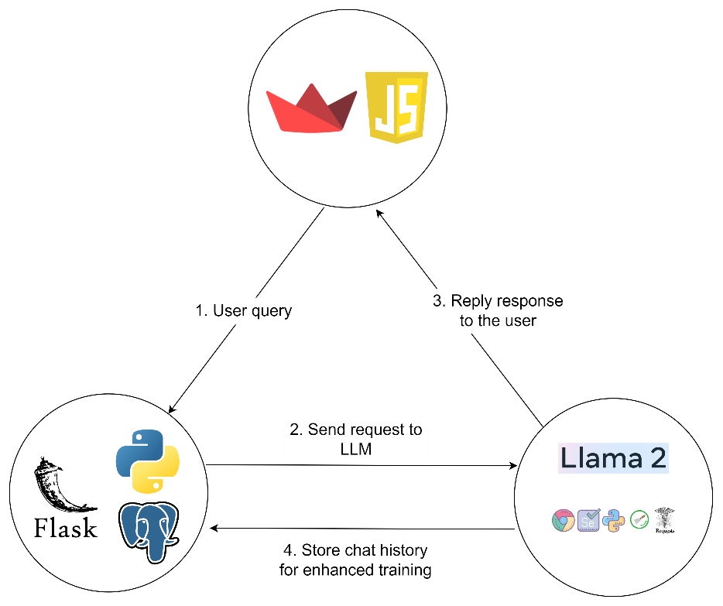

1. **Expected Outcomes**

**Improved Student Experience:**

* Students can readily access accurate and up-to-date information about courses, fees, extracurricular activities, research projects, and university news, eliminating the need to navigate complex websites or FAQs.
* The chatboengagement andze responses based on student interests and previous inquiries, enhancing engagement, and providing a more relevant experience.

**Enhanced University Operations:**

* The interactive nature of the chatbot can foster a sense of community and encourage students to actively seek information and connect with the university.
* A well-designed and helpful chatbot can contribute to a positive perception of the university, showcasing its commitment to innovation and student-centricity.

1. **Github Repositories**

Repo Link: <https://github.com/TarunSiga/DSCapstoneProject>

***Individual GitHub links (Branched with project):***

Deepka Ayyasamy:

<https://github.com/TarunSiga/DSCapstoneProject/tree/DeepakAyyasamy>

Tarun Siga:

<https://github.com/TarunSiga/DSCapstoneProject/tree/TarunSiga>

Sai Karthik Naladala:

<https://github.com/TarunSiga/DSCapstoneProject/tree/saikarthiknaladala>

1. **Responsibilities**

**Deepak Ayyasamy:**

* Web scraping data to fine-tune Llama2 model. Clean the data by removing irrelevant content, noise, and duplicate entries.
* Fine-tune Llama2 for efficient questions and answering.
* Integrate Speech-to-Text feature for the chatbot using DeepSpeech.

**Tarun Siga:**

* Design and create a visually appealing and intuitive user interface for the chatbot using Streamlit.
* Ensure that the chatbot interface works seamlessly across various web browsers, addressing any compatibility issues that may arise.
* Integrate with the back-end systems to fetch and display real-time information.

**Sai Karthik Naladala:**

* Create a Flask application to serve as the back-end for the chatbot. Configure routes to handle incoming requests, including those for user queries, chat history retrieval, and any other necessary functionalities.
* Implement the core logic of the chatbot, integrating with Llama2 for processing user queries and generating responses.
* Set up a PostgreSQL database to store chat history and relevant user interactions.
* Establish database connections within the Flask app to enable seamless storage and retrieval of chat data.